Come Fly With Me: A Sky High Gala Sponsorship Opportunities
Syracuse Hancock International Airport - Saturday, November 10, 2018 | 6:30pm – 9:30pm

1000 Col Eileen Collins Blvd, Syracuse, NY 13212

Presented by:
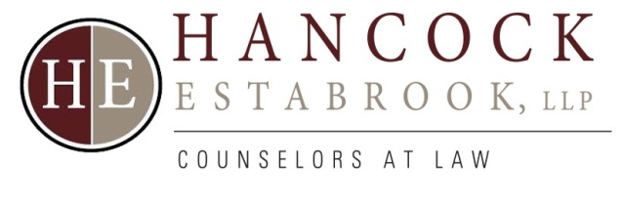

Presenting Sponsor: $10,000
- Company logo on sponsorship signage and page listing in the event program
- Primary acknowledgment in all media
- Verbal recognition from podium
- Company name or logo in OHA’s magazine, History Highlights
- Recognition on OHA’s website
- Ten (10) complimentary tickets to cocktail reception and dinner
- One year OHA Corporate Membership (value $250)
- One complimentary use of OHA’s downtown museum or Ska-nonh Center
- 50% off any size ad in History Highlights

Dinner Sponsor: $7,500
- Company logo on sponsorship signage and page listing in the event program
- Acknowledgement in all media
- Verbal recognition from podium
- Company name or logo in OHA’s magazine, History Highlights
- Recognition on OHA’s website
- Ten (10) complimentary tickets to cocktail reception and dinner
- One year OHA Corporate Membership (value $250)
- 50% off any size ad in History Highlights

Sustaining Sponsor: $5,000
- Company logo on sponsorship signage and page listing in the event program
- Acknowledgement in all media
- Verbal recognition from podium
- Recognition in OHA’s magazine, History Highlights
- Recognition on OHA’s website
- Six (6) complimentary tickets to cocktail reception and dinner
- History Highlights
- One year OHA Corporate Membership (value $250)
- 50% off any size ad in History Highlights

Supporting Sponsor: $2,500
- Company name on sponsorship signage and page listing in the event program
- Verbal recognition from podium
- Recognition in OHA’s magazine, History Highlights
- Recognition on OHA’s website
- Four (4) complimentary tickets to cocktail reception and dinner
- One year OHA Corporate Membership (value $250)
- 50% off any size ad in History Highlights

Cocktail Sponsor: $2,000
- Company name on special signage at the bar and page listing in the event program
- Recognition in OHA’s magazine, History Highlights
- Recognition on OHA’s website
- Four (4) complimentary tickets to cocktail reception and dinner
- One year OHA Corporate Membership (value $250)
- 25% off any size ad in History Highlights

Benefactor Sponsor: $1,000
- Company name on sponsorship signage and page listing in the event program
- Two (2) complimentary tickets to cocktail reception and dinner
- 25% off any size ad in History Highlights

Friend: $500
- Company logo on page listing in the event program
- Two (2) complimentary ticket to cocktail reception and dinner

